43.20: Note that Eq. 43.17 can be written as follows
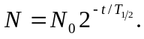
The amount of elapsed time since the source was created is roughly 2.5 years. Thus, we expect the current activity to be
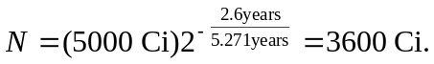
The source is barely usable. Alternatively, we could calculate 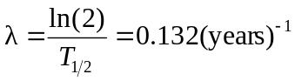
and use the Eq. 43.17 directly to obtain the same answer.

